ECG & PULSE
- Mechanical Action of the Heart, Peripheral Pressure Pulse, and Plethysmography
DATA REPORT
Student’s Name: Marek Darsa
Lab Section: L 7
Date: 19.3

- Data and Calculations
A. Comparison of ECG with Pulse Plethysmogram
Complete Table 7.1 with data from three cycles from each acquired recording and calculate the Means.
Table 7.1
Condition | Selected Area | Measurement |  |  | Cycle I | Cycle 2 | Cycle 3 |  | Mean
Arm Relaxed | R-R Interval | DeltaT | CH 1 | 0.91 |  | 0.79 | 0.9 | 0.866667
 | Heart Rate | BPM | CH 1 | 66 |  | 75 | 66.6 | 69.2
 | Pulse Interval | DeltaT | CH 1 | 0.91 |  | 0.79 | 0.88 | 0.86
 | Pulse Rate | BPM | CH 1 | 65.9 |  | 75 | 67 | 69.3
Temp. Change | R-R Interval | DeltaT | CH 1 | 0.84 |  | 0.77 | 0.77 | 0.793333
 | Heart Rate | BPM | CH 1 | 71 |  | 77 | 77 | 75
 | Pulse Interval | DeltaT | CH 1 | 0.84 |  | 0.77 | 0.77 | 0.793333
 | Pulse Rate | BPM | CH 1 | 71 |  | 77 | 77 | 75
Arm Up | R-R Interval | DeltaT | CH 1 | 0.71 |  | 0.75 | 0.72 | 0.726667
 | Heart Rate | BPM | CH 1 | 84 |  | 80 | 83 | 82.33333
 | Pulse Interval | DeltaT | CH 1 | 0.71 |  | 0.76 | 0.71 | 0.726667
 | Pulse Rate | BPM | CH 1 | 84 |  | 79 | 84 | 82.33333
- Relative Volume Changes
Complete Table 7.2 with data from each acquired recording.
Table 7.2
 | Arm Resting | Temperature | Arm Up
Measurement
QRS Amplitude  CH1 P-P | 0.71 | 0.75 | 0.73
Relative Pulse Amplitude (mV)  CH 40 P-P | 2.20 | 1.20 | 1.16

- Calculation of Pulse Speed
Distance between Subject’s sternum and shoulder? ___30________________cm
Distance between Subject’s shoulder and fingertip? ___87________________cm
Total distance? ______117____________cm

Data from ‘Arm relaxed’ recording of the recording (measure with I-Beam)
Time between R-wave and Pulse peak? ___0.4_________________secs

Speed?________________________292.5____________________cm/sec

Data from ‘Arm up’ recording of the recording (measure with I-Beam)
Time between R-wave and Pulse peak? _______0.37_____________secs

Speed?_______________316,21_____________________________cm/sec

II. Questions

- Referring to Table 7.2 data, how much did the amplitude of the QRS complex change between conditions?
Extreme temp – Arm Resting? __0.04________ mV
Arm up – Arm Resting? ____-0.02________ mV
- Referring to Table 7.2 data, how much did the pulse amplitude change between arm positions?
Extreme temp – Arm Resting? _____-1_____ mV
Arm up – Arm Resting? _____-0,4_______ mV

III. Theory

- Name the anatomical parts of the heart and draw direction of blood flow into the picture:

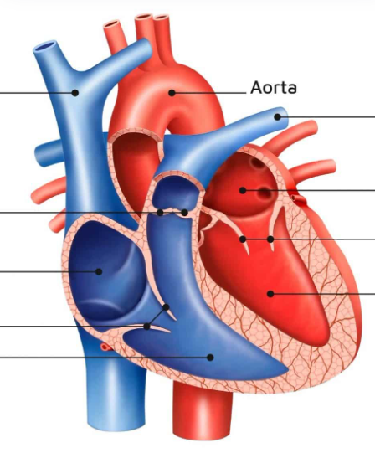

- Label the sketch below with the key parts of the transmission system.
- Bundle of His
- Muscle tissue of atrium
- Purkinje fibers
- Atrioventriucular node
- Ventricular muscle tissue
- Sinoatrial node
- Right and left (Tawar) bundle/arm

Describe the transmission of the electrical signal throughout the heart. Use the names of the key parts from above:
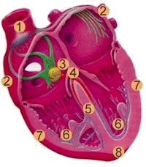

________________________________________________________________________________________________________________________________________________________________________________________________________________________________________________________________________________________________________________________________________________________________________________________________________________________________________________________________________________________________________________________________________________________________________________________________________________________________________________________________________________________________________________________________________________________________________________________________________________________

End of Lesson 7 Data Report

